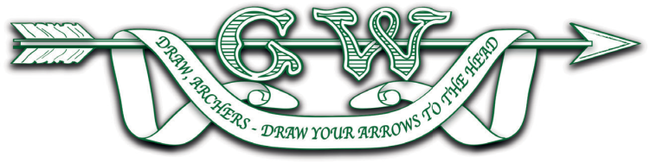

2024 NOMINATION FORM
for
Officers, Council, Specialist Officers & Members

We wish to propose ___________________________________________________

For the position of ___________________________________________________

Proposed by (please print name & sign) __________________________________________________

Seconded by (please print name & sign) __________________________________________________

Proposal dated _________________________________________________

I agree to stand for the above post _________________________________________________
(please print name & sign)

If elected, I agree that my telephone number – e-mail address (please delete as required) may be displayed on the GWAS website.

Telephone number _____________________________________________

E-mail address _____________________________________________

Completed nomination forms for the positions of President, Chairman, Hon. Secretary and Hon. Treasurer should be returned to the Hon. Secretary, GWAS email: secretary@gwas.org.uk
to arrive no later than 1.15pm on Sunday 17th March 2024.
Whilst the GWAS constitution allows that nominations for other positions may be submitted on the day of the AGM, we would ask that they are provided by noon on Friday 22nd March, if at all possible.

