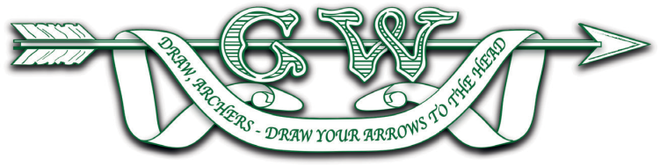

**GRAND WESTERN ARCHERY SOCIETY E.G.M. CALLING NOTICE**

IN ACCORDANCE WITH CLAUSE 38 & 40 OF THE G.W.A.S. CONSTITUTION, I, DENISE BUNCE, HONORARY SECRETARY OF THE GRAND WESTERN ARCHERY SOCIETY, HEREBY GIVE NOTICE THAT AN EXTRAORDINARY GENERAL MEETING OF THE SOCIETY WILL TAKE PLACE AT WEST BUCKLAND VILLAGE HALL, WEST BUCKLAND, SOMERSET TA21 9NA AT 1.15PM ON SUNDAY 23RD MARCH 2025.

The Coaching Meeting will be held beforehand at 12.45pm

The Annual General Meeting will be held at 1.45pm

**AGENDA**

1. Apologies for absence
2. Motions for the EGM to consider:

*Background to the Motions proposed: The following Motions are predicated on the decision already made by the Grand Western Council to adopt the change previously made by Archery GB to annualized membership, with the regional renewal date matching the date set by Archery GB, wherever possible.*

1. That GWAS drop the pro-rating of affiliations from 1st April 2025.
2. That GWAS change the affiliation age groups to match the new Archery GB structure, as per the draft circulated.
3. That this EGM confirms the fee structure applying to all clubs within the Region for 2024/25, to be applied to everyone during the affiliation year from 1 October 2024 to 30 September 2025 (2024/25), as per the draft circulated.
4. That this EGM confirms the alterations to the GWAS Constitution, as per the draft circulated.

Please find attached a briefing note explaining the amendments required regarding the administration of the Grand Western Archery Society Affiliations to come in line with Archery GB.

Also attached is the Grand Western Archery Society Constitution with the proposed changes clearly marked.