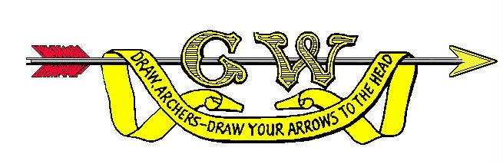
Grand Western Archery Society Expenses Claim Form
All claims for expenses (excluding mileage) must include receipted bills
Name & Address of Claimant
 |  |  | Post Code |  | Date
Event or Duty
Venue | N/A

Travel
 |  |  | Total
Car | Miles at 40p per mile |  | £
 | Road Toll Fees (M6 Expressway) |  | £
 | Tunnel or Bridge Crossings |  | £
Rail | Second Class Fare |  | £
 | Bus |  | £
 | Tube |  | £
1 | Sub Total for Travel |  | £

Other Permitted Expenses eg. Course Fees
Details |  | £
 |  | £
 |  | £
 |  | £
 |  | £
2 | Sub Total for other permitted expenses | £#

Breakfast | Claimable if absent from home before 07.00hrs for a duration of not less than 5 hours
Lunch | Claimable if absent from home more than 5 hours, extended over the morning and afternoon (before and after mid-day)
Evening Meal | Claimable if absent from home more than 5 hours, extended into the evening (after 18.00hrs)
Accommodation | Claimable for overnight accommodation. If breakfast and evening meal are included, the above rates cannot be claimed in addition.

Meals
 |  |  |  | Total
Breakfast | Number |  |  | £
Lunch | Number |  |  | £
Evening Meal | Number |  |  | £
Each Period of 24 hours should be treated as separate periods and claimed for as above. |  |  |  | £
3 |  |  | Sub Total for Meals | £

Accommodation
 |  |  |  |  | Total
Price per night | £ |  | Number of Nights
4 |  | Sub Total for Accommodation |  |  | £

Please remember to attach all receipts relating to this claim.

All claims will be reviewed and checked before payment is made.

Total of Claim 1+2+3+4 | £

Signature of Claimant
Authorised by (Print Name)
Signature of Authoriser

I certify that I have not claimed any of the above expenses from another source

All expenses will be paid by Bank Transfer.

Please fill in the section below.

Bank
Account Name
Sort Code
Account Number

